Rochester, NY’s Newest OLYMPIAN--Miranda Melville!
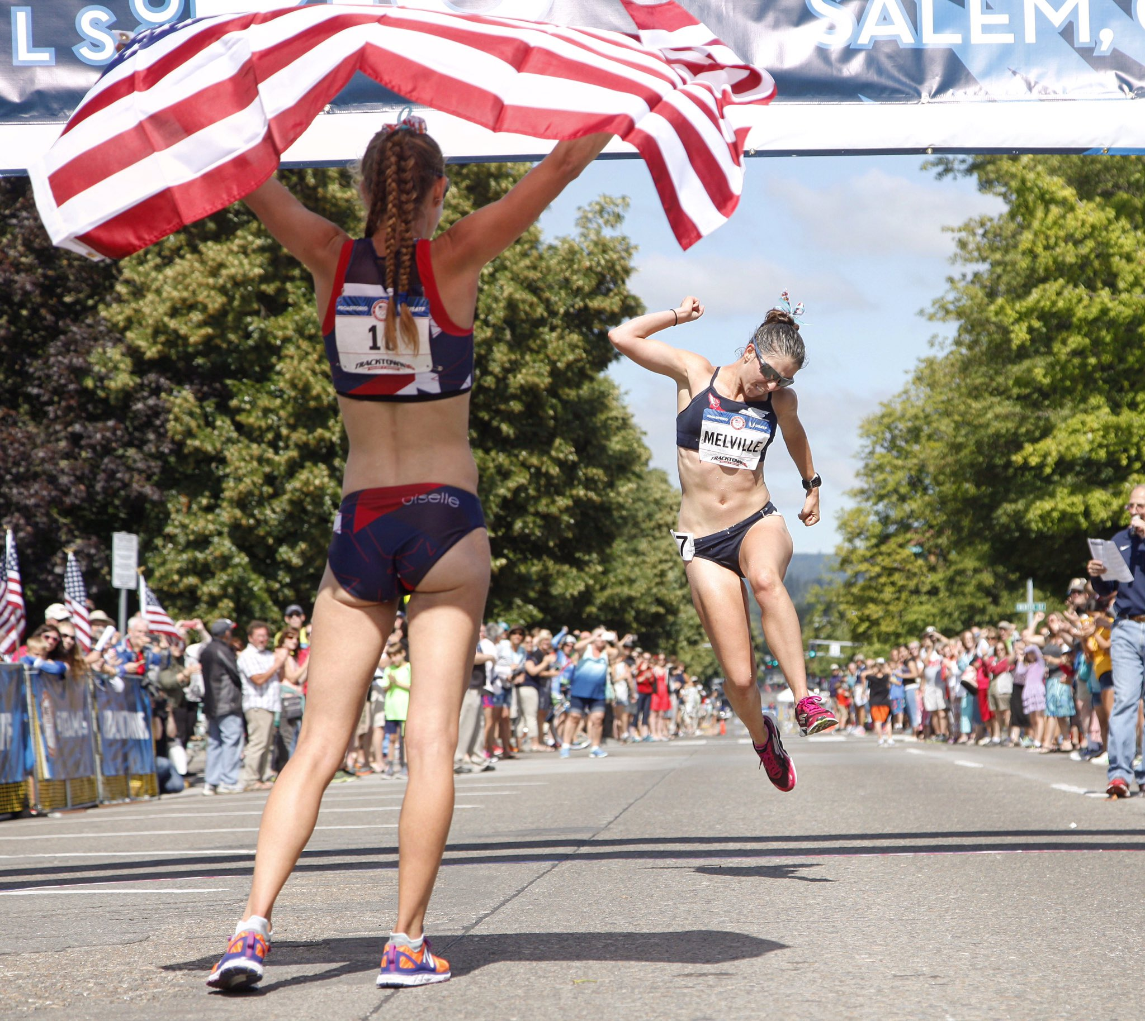  Miranda Melville jumps for joy at making the USA Olympic Team.(Photo by USATF) | For Immediate Release:  Miranda Melville 585-313-2127 or  manager@mirandaracewalks.com  (Salem, OR., June 30, 2016)  Miranda Melville a 2007 R-H graduate has earned a spot on the 2016 USA 20-k Olympic Race Walk team at the USATF Olympic Trials in Salem OR.  Miranda said, “I am living on cloud 9 and I am going to stay here the next couple of days. I am so proud of everyone who competed. I can't thank my coach, all my friends, family and teammates enough for making this moment so wonderful”.  2x Olympian and Race Walk Coach Tim Seaman said, “It took 4 long years to make up 2.2 seconds. The thrill of watching Miranda qualify for her first Olympic team was well worth the thousands of miles we did together.”  Miranda, who took silver, is one of only two women in the USA to make the 2016 race walk team. She missed the 2012 games by just under 3 seconds.  -For more information see www.MirandaRaceWalks.com or  -Skype or telephone contact Miranda at 585-313-2127.  -To donate to Miranda’s Olympic journey visit https://www.flipcause.com/secure/cause_pdetails/NzIwMQ==  ‪Video - Miranda Melville Excited to be a 2016 Olympian!‬  YouTube video - by C. Melville https://www.youtube.com/watch?v=vJux29k9-2g
  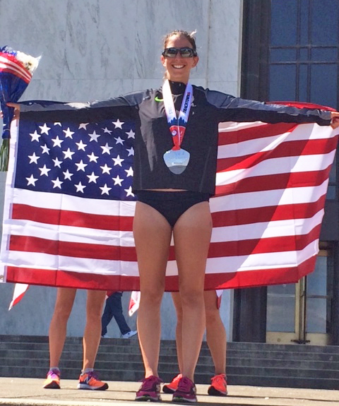
  Photo by C. Melville

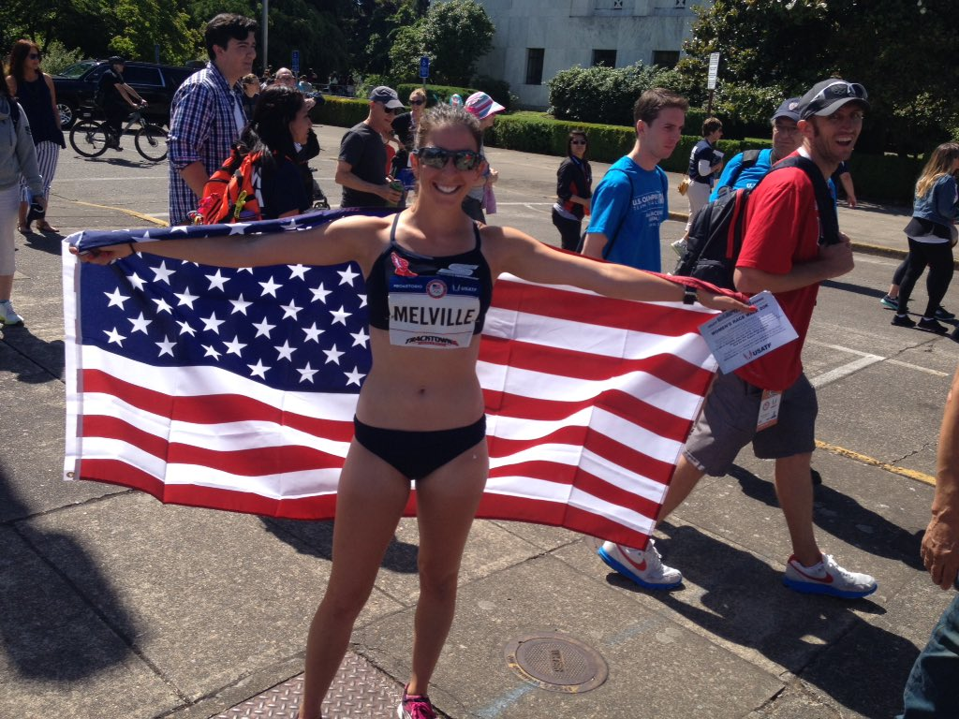
Photos by C. Melville



